Date: 21.02.2025
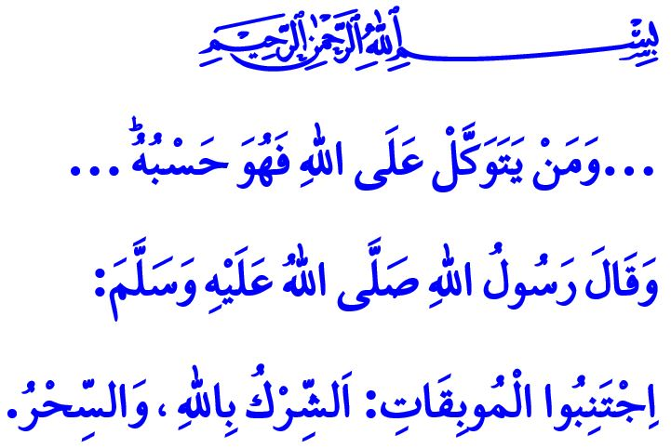
THE KNOWLEDGE OF THE UNSEEN BELONGS ONLY TO ALLAH
Honorable Muslims!
From time to time, we come across those who practice and seek magic and sorcery. We witness soothsayers, fortune-tellers, mediums, amulet-makers, and charlatans who exploit people’s emotions and earnings for worldly gains. Some television channels and digital platforms provide an environment that enables these evildoers. In today’s khutbah, let us remember and remind ourselves of how our sublime religion, Islam, views these matters.
Dear Believers!
According to our religion, magic and sorcery are grave sins. The Messenger of Allah (saw) stated, “Avoid destructive sins such as associating partners with Allah and practicing magic.” Engaging in or resorting to magic and sorcery is a violation of people’s rights and an act of oppression. It is a reprehensible attitude and behavior that contradicts our belief in tawhid and our understanding of tawakkul. Those who commit this sin can never escape Allah’s wrath unless they sincerely repent and seek forgiveness from those whose rights they have violated.
Esteemed Muslims!
Jinn, like humans, are servants of Allah. Among them are both believers and non-believers. However, just like humans, they do not possess knowledge of the unseen. Without Allah’s permission, they cannot harm anyone. وَلِلّٰهِ غَيْبُ السَّمٰوَاتِ وَالْاَرْضِ “To Allah ˹alone˺ belongs the knowledge of what is hidden in the heavens and the earth.” Therefore, those who claim to communicate with jinn and receive knowledge of the future from them are outright liars. A Muslim’s duty is to seek refuge in Allah from the evil of both humans and jinn, just as they seek protection from other harms. One should remain steadfast in worship and prayer and, as advised by the Prophet (saw), frequently recite Surah al-Falaq and Surah an-Nas for protection. Furthermore, as stated in the verse, all forms of fortune-telling using blessings such as coffee, tea, salt, or beans, رِجْسٌ مِنْ عَمَلِ الشَّيْطَانِ “are all evil of Satan’s handiwork” It is haram and sinful to make predictions about the future through cards, horoscopes, palm reading, or facial analysis. Sharing these falsehoods through television, newspapers, or social media is a grave sin that carries a heavy accountability. The warning of the Messenger of Allah (saw) is clear: “Whoever rejects what Allah has revealed and goes to a soothsayer or fortune-teller and believes in their words has disbelieved in what was revealed to the Prophet Muhammad.”
Esteemed Believers!
Allah the Almighty states, “We send down the Qur’an as a healing and mercy for the believers.” The Holy Qur’an was revealed to be recited, understood, and lived by. The solution to both our individual and societal struggles lies within it. While seeking medical treatment for our illnesses, reciting the Qur’an and praying to Allah with the supplications of our beloved Prophet (saw) bring healing to our bodies and tranquility to our souls. However, using Qur’anic verses or supplications by writing them on paper or blowing over people as a means of financial gain has no place in our religion.
Dear Muslims!
Those who practice magic and sorcery are sorcerers. Those who engage with jinn are jinn-conjurers. Those who tell fortunes are fortune-tellers. Those who write amulets for personal gain are amulet-makers. Those who claim to heal people by blowing over them are charlatans. None of these individuals are “hodjas”. Equating such people with our hodjas, who are the heirs of our beloved Prophet (saw), leads to the legitimization and spread of these haram acts. All these false beliefs and superstitions take root in societies where a firm belief in tawhid and a sound understanding of religion are lacking. This clearly shows us the absolute necessity of authentic and correct religious knowledge, the indispensability of Qur’an-and-Sunnah-based religious education, and the grave dangers of exploitation of religion.
Dear Believers!
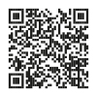
Let us remain vigilant against those who exploit our religion’s values and manipulate people’s emotions. Let us never be deceived by superstitious individuals who cannot even cure their own ailments or heal their own illnesses. Let us never give credence to bid‘ah practitioners who invite people to gatherings by falsely claiming they will distribute water in which the Prophet’s (saw) hair or beard was washed. When seeking healing, success, sustenance, and fortune, let us first fulfill our responsibilities and then place our trust in Allah. Let us always remember that no person or method can bring benefit or harm to anyone without Allah’s permission. Absolute decree belongs to Allah alone. Let us conclude with the words of our Lord: “…And whoever puts their trust in Allah, then He ˹alone˺ is sufficient for them…”

Bukhari, Tibb, 48.
Nasa’i, Muharaba, 19.
Hud 11/123.
Tirmizî, Tıb, 16.
Ma’idah, 5/90.
Ibn Majah, Taharah, 122.
Isra, 17/82.
Talaq, 65/3. General Directorate of Religious Services

